ANIL NEERUKONDA INSTITUTE OF TECHNOLOGY & SCIENCES (AUTONOMOUS)
(Permanent Affiliation by Andhra University & Approved by AICTE Accredited by NBA (ECE, EEE, CSE, IT, Mech, Civil & Chemical) & NAAC with A+ Grade)
Sangivalasa-531162, Bheemunipatnam Mandal, Visakhapatnam District.
A PROJECT WORK REPORT ON..
ONLINE EXAMINATION SYSTEM
This project is submitted by

K.SREE HARSHA A25126510025
G.C.K.ADHITYA A25126510011
K.LOHITH A25126510021
J.V.S JASWANTH A25126510018

Under the Guidance of Dr B.MAHESH
Department of Computer Science and Engineering
in partial fulfillment of the requirements for the award of the offered by

ANIL NEERUKONDA INSTITUTE OF TECHNOLOGY AND SCIENCES

Bachelor of Technology
in
COMPUTER SCIENCE AND ENGINEERING
2025-2026
ANIL NEERUKONDA INSTITUTE OF TECHNOLOGY & SCIENCES (AUTONOMOUS)
(Permanent Affiliation by Andhra University & Approved by AICTE Accredited by NBA (ECE, EEE, CSE, IT, Mech, Civil & Chemical) & NAAC with A+ Grade)
Sangivalasa-531162, Bheemunipatnam Mandal, Visakhapatnam District


CERTIFICATE

This is to certify that this project work entitled — “ONLINE EXAMINATION SYSTEM” is the bona fide record work done by Mr.

K.Sree harsha,Mr.G.C.K Adhitya,Mr.Lohith and Mr.J.V.S Jaswanth bearing Roll no A25126510025,A25126510011,A25126510021

and A25126510018 of the second year , along with batch mates submitted on the partial fulfillment of the requirement for the award of B.tech in Computer Science and Engineering to the ANIL NEEKURONDA INSTITUTE OF TECHNOLOGY AND SCIENCES. The results embodied in this project report have not been submitted to any other board/University or Institute for the award of diploma.

HEAD OF THE DEPARTMENT LECTURER IN CHARGE
ACKNOWLEDGEMENT

I would like to express my sincere gratitude to all those who have contributed to the successful completion of this project.

First and foremost, I extend my heartfelt thanks to my project guide,
DR B.MAHESH, for their valuable guidance, continuous support, and encouragement throughout the development of this project. Their insightful feedback and expert advice were instrumental in shaping this work.
I am also grateful to the faculty members of Computer Science and Engineering, ANIL NEERUKONDA INSTITUTE OF TECHNOLOGY AND SCIENCES, for providing the
necessary resources and a conducive environment for research and learning.

A special thanks to my friends and classmates for their cooperation, constructive suggestions, and moral support during every stage of this project.
Finally, I would like to thank my family for their unwavering love, patience, and constant motivation that kept me focused and determined.

This project, titled “ONLINE EXAMINATION SYSTEM”, has been a great learning experience, helping me enhance my technical skills and practical understanding of the subject.
ABSTRACT

The Online Examination System is developed to simplify and automate the process of conducting exams in educational institutions. This system enables administrators to create andmanage question papers, while students can log i
and attempt exams within a fixed time duration.

The system evaluates answers automatically and displays results immediately after completion. It minimizes manual correction work, reduces errors, and improves efficiency in handling examinations.

The project is implemented using C++ and utilizes Object-Oriented Programming concepts along with file handling techniques to store and retrieve data. It provides a structured and reliable way to conduct examinations digitally.

Table of contents

S.NO | CHAPTER TITLE | SUB-CONTENTS | PAGE NO
1 | Introduction | Overview of the project  Purpose and scope  Existing system  Proposed system | 1
2 | Problem definition | Problem statement  Objectives of the class | 2
3 | System design | System architecture  Algorithms used | 2-4
4 | Implementation details | Program structure  Language and environment used  Key functional modules  Code snippets  Filehandling explanation | 4-8
5 | Results and discussion | Output screens  Test case table | 9-11
6 | Conclusion | Summary of achievements  Limitations of the system  Future enhancements | 12
7 | References | Books referred  Research papers  Websites and online resources | 12
8 | Appendix | Source code listings  Source code  Plagiarism check | 13-17

INTRODUCTION

Overview of the project
The Online Examination Evaluation System is a console-based application developed in C++ that simulates a basic digital examination platform. It enables an administrator to create and manage multiple-choice questions, while allowing students to log in, take exams within a specified time limit, and receive immediate evaluation of their performance.The system is built using object-oriented programming principles and utilizes file handling to store and retrieve question data.

Purpose
The purpose of the Online Examination System is to provide a simple, efficient, and automated platform for conducting examinations digitally. It aims to reduce the drawbacks of traditional paper-based exams by enabling quick question management, timed assessments, and instant result evaluation. The system helps in minimizing manual effort, reducing errors in checking, and improving overall efficiency in the examination process

Scope
The scope of this project is limited to a console-based application developed in C++ that supports basic examination functionalities. It includes:
- Admin functionality to add and store multiple-choice questions
- Student login to attempt exams
- Time-based question answering
- Automatic evaluation and score calculation
- File handling for storing and retrieving questions
This system is suitable for small-scale use such as classroom tests or practice exams. It does not include advanced features like database integration, online networking, or graphical user interface, but it provides a strong foundation for future enhancements

Existing System
The existing examination system is mainly based on the traditional paper-based method.
Question papers are distributed manually, and students write answers on paper.
Evaluation is done by teachers, which is time-consuming and requires effort.
There is a high chance of human errors in checking and result calculation.
Managing records and storing answer sheets is difficult and inefficient.
The system does not provide instant results or feedback to students.

Proposed System
The proposed system is a console-based online examination system developed in C++.
It allows the admin to add and manage multiple-choice questions digitally.
Students can log in and attempt exams within a specified time limit.
The system automatically evaluates answers and calculates scores instantly.
It reduces manual effort, errors, and time consumption.The system provides quick results and improves overall efficiency of the examination process.

PROBLEM DEFINATION

Problem statement
The current examination system relies on manual processes that are time-consuming, error-prone, and inefficient. Evaluating answer sheets and generating results requires significant effort and delays feedback to students. Managing large volumes of data and maintaining records is also challenging. Therefore, there is a need for an automated online examination system that can conduct exams, evaluate responses accurately, and provide quick results.

Objectives of the system

- To develop a simple and user-friendly online examination system
- To automate the process of conducting exams and evaluating answers
- To reduce manual effort and minimize human errors
- To implement time-based examination for better assessment
- To provide instant results and feedback to students
- To efficiently manage and store question data using file handling

SYSTEM DESIGN

System Architecture
The system is designed using a modular approach where each class represents a separate component responsible for a specific functionality. This ensures better organization, readability, and maintainability of the code.
The User class handles authentication for both admin and student. It verifies login credentials and controls access to different functionalities of the system. Admin users are allowed to add questions, while students are allowed to take exams.
The Question (que) class is responsible for storing and managing question data. It contains the question text, multiple-choice options, and the correct answer. It also provides a function to display the question and its options during the exam.
The Exam class manages the overall examination process. It allows the admin to add questions, loads questions from a file, conducts the exam, checks answers, and calculates the final score. It acts as the core component of the system.
The Timer class is used to control the time limit for each question. It tracks the start time and calculates the remaining time, ensuring that students answer within the specified duration.
All these classes work together to form a simple and efficient online examination system.
Algorithms used

1. Login Algorithm
- Start
- Enter username and password
- Compare with stored credentials
- If matched → Login successful
- Else → Display invalid login message

2. Add Question Algorithm (Admin)
- Start
- Enter number of questions and time per question
- For each question:
  - Enter question text
  - Enter four options
  - Enter correct answer
- Store all data in file
- End

3. Load Question Algorithm
- Start
- Open question file
- Read time per question
- Read question, options, and correct answer
- Store in vector
- Repeat until end of file
- Close file
- End

4. Exam Execution Algorithm
- Start
- Load questions
- Initialize score = 0
- For each question:
  - Start timer
  - Display question and options
  - Accept user answer
  - Check if time expired
  - If not expired:
    - Compare answer with correct answer
    - Update score
- Repeat for all questions
- Display final score
- End

5. Timer Algorithm
- Start
- Record current time
- Calculate elapsed time
- If elapsed time ≥ limit → Time expired
- Else → Time remaining
- End

IMPLEMENTATION DETAILS

Program structure
The program is organized using a structured and object-oriented approach, where different classes handle specific functionalities of the system. This modular design makes the code easy to understand, manage, and extend.
The program begins with the main() function, which acts as the entry point. It displays a menu for selecting the role (admin or student) and calls the appropriate functions based on user input.
The User class handles login operations for both admin and student by verifying credentials.
The Question (que) class is used to store question details such as the question text, options, and the correct answer, and also provides a method to display them.
The Exam class manages the core functionality of the system, including adding questions, loading questions from the file, conducting the exam, and calculating the final score.
The Timer class is responsible for managing the time limit for each question by tracking the start time and calculating the remaining time.
All these components work together in a logical sequence to perform the complete examination process efficiently.

language and environment used
The project is developed using the C++ programming language, which supports object-oriented programming concepts such as classes, objects, and file handling. C++ is chosen for its efficiency, simplicity, and suitability for console-based applications.
The development and execution of the program can be done using compilers like Turbo C++, Code::Blocks, or g++. The system runs in a console (command-line) environment, where users interact through keyboard input and screen output.
Standard libraries such as <iostream>, <fstream>, <vector>, <string>, and <ctime> are used to handle input/output operations, file management, dynamic data storage, and time control within the program.

key functional modules with code snippets

1. User Authentication Module
This module handles login for both admin and student by verifying credentials.
class user{
public:
int adminlogin(){
string u,p;
cout<<"Admin name:";
cin>>u;
cout<<"Admin password:";
cin>>p;
if(u=="admin" && p=="admin123")
return 1;
cout<<"invalid login"<<endl;
return 0;
}
int stulogin(){
string u,p;
cout<<"student name:";
cin>>u;
cout<<"student password:";
cin>>p;
if(u=="student" && p=="stu123")
return 1;
cout<<"invalid login"<<endl;
return 0;
}
};

2. Question Management Module
This module stores and displays questions with options and correct answers.
class que{
public:
string q,o1,o2,o3,o4,corr;
void displayque(){
cout<<q<<endl;
cout<<"1:"<<o1<<endl;
cout<<"2:"<<o2<<endl;
cout<<"3:"<<o3<<endl;
cout<<"4:"<<o4<<endl;
}
};

3. Exam Management Module
This module controls adding, loading, and conducting the exam.
void addquestion(){
int n,t;
cout<<"Enter no of questions";
cin>>n;
cout<<"Enter time per que";
cin>>t;
cin.ignore();
ofstream f("questions.txt");
f<<t<<endl;
for(int i=0;i<n;i++){
que qo;
getline(cin,qo.q);
getline(cin,qo.o1);
getline(cin,qo.o2);
getline(cin,qo.o3);
getline(cin,qo.o4);
cin>>qo.corr;
cin.ignore();
f<<qo.q<<endl<<qo.o1<<endl<<qo.o2<<endl
<<qo.o3<<endl<<qo.o4<<endl<<qo.corr<<endl;
}
f.close();
}

4. Timer Module
This module controls time for each question.
class timer{
int limit;
time_t start;
public:
timer(int s){
limit=s;
start=0;
}
void startTimer(){
start=time(0);
}
int timeLeft(){
return limit-(time(0) - start);
}
int expired(){
return timeLeft()<=0;
}
};

5. Exam Execution & Evaluation Module
This module conducts the exam and calculates the score.
void startexam() {
int score = 0;
string ans;
for (int i = 0; i < questions.size(); i++) {
timer to(timeque);
to.startTimer();
questions[i].displayque();
cin >> ans;
if (to.expired()) {
cout << "Time's up!"<<endl;
} else {
if (ans == questions[i].corr) {
score++;
}
}
}
cout<<"FinalScore:"<<score<<"/"<<questions.size()<<endl;
}
These modules together form the complete working of the online examination system.

File handling explanation
File handling is used in this project to store and retrieve exam questions permanently using the fstream library in C++. It allows the system to save data in a file so that it can be reused later without re-entering the questions.
When the admin adds questions, the program uses ofstream to write data into a file named questions.txt. The file stores the time per question followed by the question, options, and correct answer in a structured format.
During the exam, the system uses ifstream to read data from the same file. The questions, options, and answers are loaded into a vector for processing and display.
Each question is stored line by line, making it easy to read sequentially. The file is opened before operations and properly closed after reading or writing to ensure data safety.
This approach provides simple data persistence without using a database and makes the system efficient for small-scale applications.

RESULTS AND DISCUSSION

Output screens

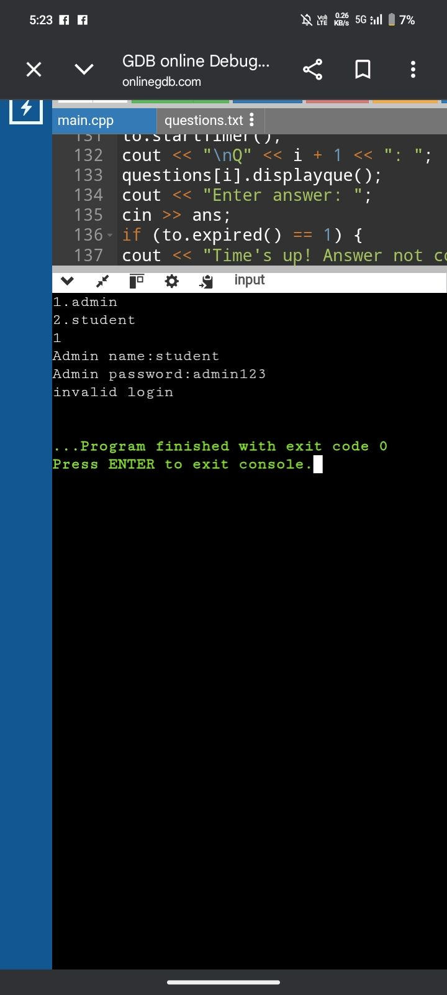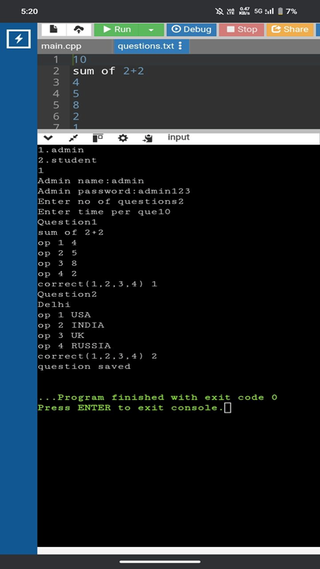

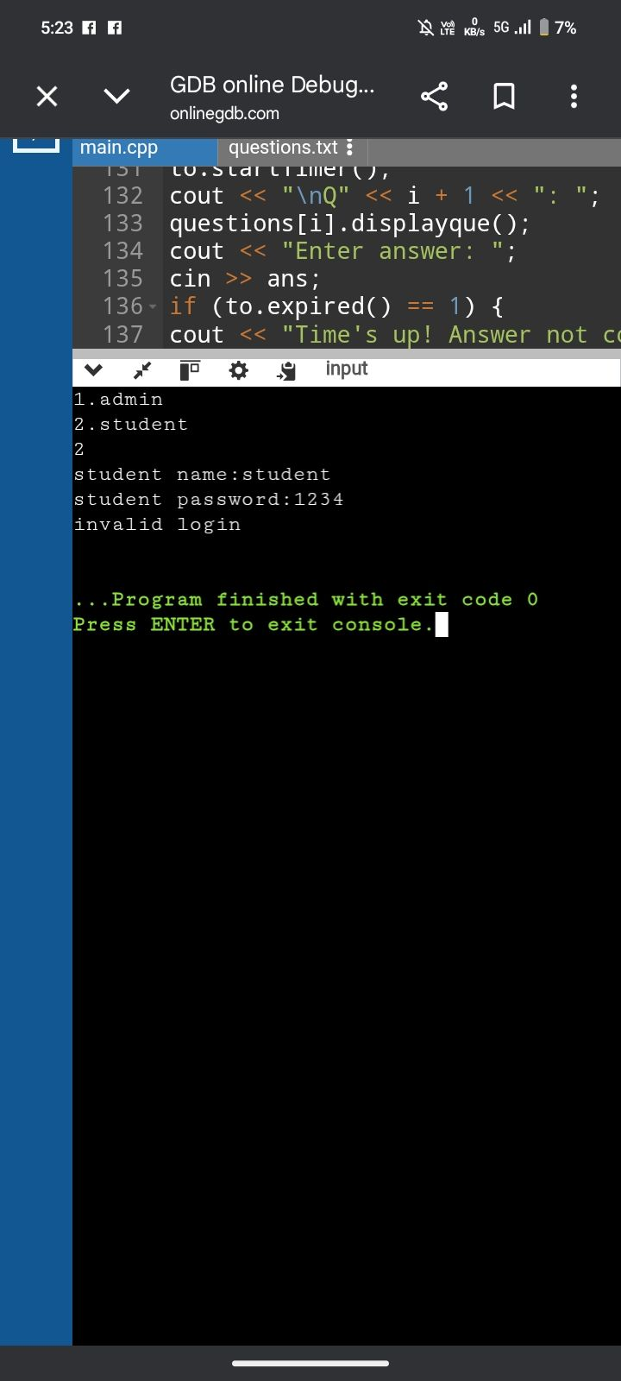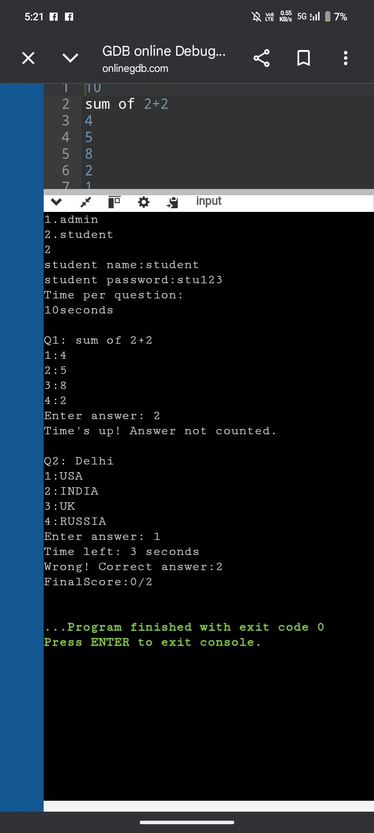

Test Case Table
Test Case ID | Input | Expected Output | Actual Output | Status
TC01 | Correct admin login | Access to add questions | Access granted | Pass
TC02 | Incorrect admin login | Error message | "Invalid login" displayed | Pass
TC03 | Correct student login | Exam starts | Exam started | Pass
TC04 | Incorrect student login | Error message | "Invalid login" displayed | Pass
TC05 | Enter correct answer | Score increases | Score increased | Pass
TC06 | Enter wrong answer | Score remains unchanged | Score unchanged | Pass
TC07 | Time exceeds limit | Answer not counted | "Time's up" message shown | Pass
TC08 | No question file present | Error message | "No question file found" displayed | Pass
TC09 | Valid question input by admin | Questions saved to file | Questions saved successfully | Pass
TC10 | Complete exam | Final score displayed | Score displayed correctly | Pass

CONCLUSION

Summary of achievements
- Successfully developed a functional online examination system using C++
- Implemented object-oriented programming concepts such as classes and objects
- Designed modules for user authentication, question management, and exam execution
- Achieved automatic evaluation and score calculation
- Implemented file handling for storing and retrieving questions
- Incorporated a basic timer mechanism for time-based exams
- Created a simple and efficient console-based user interface

Limitations of the system
· Uses hardcoded login credentials, making it less secure
· Timer is not strictly enforced due to input blocking
· Limited to a console-based interface (no graphical UI)
· No database integration, relies only on text files
· Does not support multiple users or user registration
· Lacks advanced features like question randomization and result history

Future Enhancements
- Implement a secure login system with user registration and encrypted passwords
- Integrate a database (MySQL/SQLite) for better data management
- Develop a graphical user interface (GUI) or web-based platform
- Add strict timer functionality with auto-submit feature
- Include randomization of questions and options
- Maintain student result history and performance analysis
- Support multiple subjects and categories
- Enable multi-user access for larger scale applications

REFERENCES
Cpp programming books
Online tutorials
Programming documentation
Use ai such as openai and other for reference

APPENDIX

#include<iostream>
#include<fstream>
#include<vector>
#include<string>
#include<ctime>
using namespace std;

class timer{
int limit;
time_t start;
public:
timer(int s){
limit=s;
start=0;
}
void startTimer(){
start=time(0);
}
int timeLeft(){
return limit-(time(0) - start);
}
int expired(){
if(timeLeft()<= 0)
return 1;
else
return 0;
}
};

class user{
public:
int adminlogin(){
string u,p;
cout<<"Admin name:";
cin>>u;
cout<<"Admin password:";
cin>>p;
if(u=="admin" && p=="admin123")
return 1;
cout<<"invalid login"<<endl;
return 0;
}

int stulogin(){
string u,p;
cout<<"student name:";
cin>>u;
cout<<"student password:";
cin>>p;
if(u=="student" && p=="stu123")
return 1;
cout<<"invalid login"<<endl;
return 0;
}
};

class que{
public:
string q,o1,o2,o3,o4,corr;

void displayque(){
cout<<q<<endl;
cout<<"1:"<<o1<<endl;
cout<<"2:"<<o2<<endl;
cout<<"3:"<<o3<<endl;
cout<<"4:"<<o4<<endl;
}
};

class exam{
vector<que>questions;
int timeque;

public:
void addquestion(){
int n,t;
cout<<"Enter no of questions";
cin>>n;
cout<<"Enter time per que";
cin>>t;
cin.ignore();
ofstream f("questions.txt");
f<<t<<endl;
for(int i=0;i<n;i++){
que qo;
cout<<"Question"<<i+1<<" "<<endl;
getline(cin,qo.q);
cout<<"op 1 ";
getline(cin,qo.o1);
cout<<"op 2 ";
getline(cin,qo.o2);
cout<<"op 3 ";
getline(cin,qo.o3);
cout<<"op 4 ";
getline(cin,qo.o4);
cout<<"correct(1,2,3,4) ";
cin>>qo.corr;
cin.ignore();

f<<qo.q<<endl<<qo.o1<<endl<<qo.o2<<endl<<qo.o3<<endl<<qo.o4<<endl<<qo.corr<<endl;
}

f.close();
cout<<"question saved"<<endl;
}
void loadquestions() {
ifstream f("questions.txt");
if (!f) {
cout << "No question file found"<<endl;
return;
}
f >> timeque;
f.ignore();
que qo;
while (getline(f, qo.q)) {
getline(f, qo.o1);
getline(f, qo.o2);
getline(f, qo.o3);
getline(f, qo.o4);
getline(f, qo.corr);
questions.push_back(qo);
}
f.close();
}
void startexam() {
int score = 0;
string ans;
cout << "Time per question: " << endl<<timeque<< "seconds"<<endl;
for (int i = 0; i < (int)questions.size(); i++) {
timer to(timeque);
to.startTimer();
cout << "\nQ" << i + 1 << ": ";
questions[i].displayque();
cout << "Enter answer: ";
cin >> ans;
if (to.expired() == 1) {
cout << "Time's up! Answer not counted."<<endl;
} else {
cout << "Time left: " << to.timeLeft() << " seconds"<<endl;
if (ans == questions[i].corr) {
cout << "Correct"<<endl;
score++;
} else {
cout<<"Wrong! Correct answer:"<<questions[i].corr<<endl;
}
}
} cout<<"FinalScore:"<<score<<"/"<<questions.size()<<endl;
}
};

int main(){
user u;
exam e;
int ch;
cout<<"1.admin"<<endl<<"2.student"<<endl;
cin>>ch;
if(ch==1){
if(u.adminlogin()==1){
e.addquestion();
}
}
else if(ch==2){
if(u.stulogin()==1){
e.loadquestions();
e.startexam();
}
}
else{
cout<<"invalid"<<endl;
}
return 0;
}

Plagiarism check

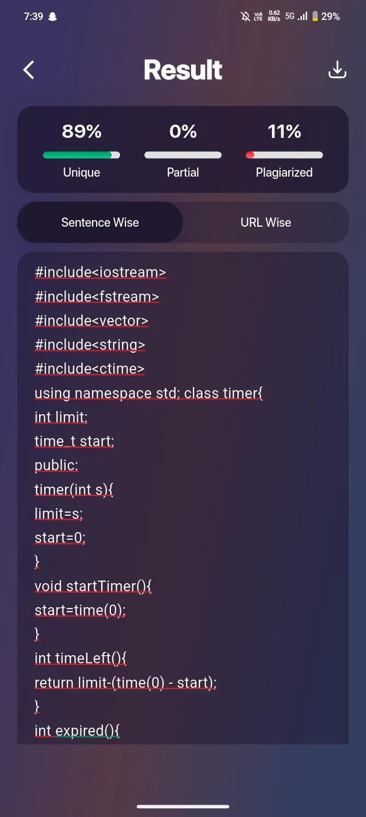

Applicationlink:
https://play.google.com/store/apps/details?id=com.plagiarismchecker_plagiarismremover

